**Luxury Scotland**

**Day 1 – Arrive at Glasgow**

Arrive at Glasgow Airport in the early morning, meet your private driver and depart for Cameron House Hotel on the bank of Loch Lomond, where you will enjoy your first two nights in Scotland.

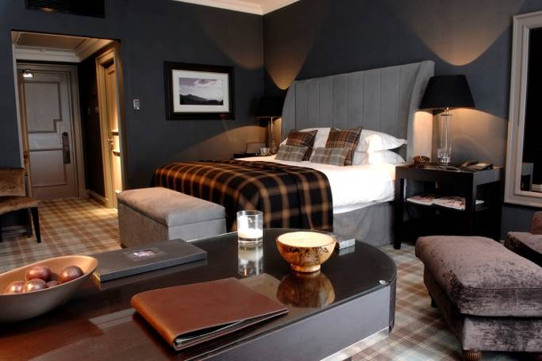**Cameron House Hotel:**

A splendid, sophisticated retreat among Loch Lomond accommodation, where traditional Scottish aesthetic meets the high style of modern luxury. Cameron House on Loch Lomond, a sumptuous baronial mansion set within 100 wooded acres is voted one the country’s most stylish hotels, this five-star Loch Lomond accommodation offers an unforgettable experience in the form of 132 warmly elegant guestrooms, exquisite haute cuisine, two challenging golf courses, and the serene Spa at the Carrick. The hotel offers 4 restaurants including formal dining in the shape of Martin Wisharts awarded Michelin star Restaurant.

Your room will be ready for your arrival, where you can refresh before joining your driver and departing for Glasgow city centre.

**Glasgow:**

Glasgow, Scotland's largest city, is renowned for its culture, style and the friendliness of its people. Glasgow offers a blend of internationally-acclaimed museums and galleries and stunning architecture. Vibrant and energetic, Glasgow enjoys a year-round buzz with an arts scene that regularly produces cutting-edge productions and attracts high-profile exhibitions that led to the city being crowned European City of Culture in 1990. Glasgow was also the UK's City of Architecture and Design in 1999 and its architecture is an attraction in itself.

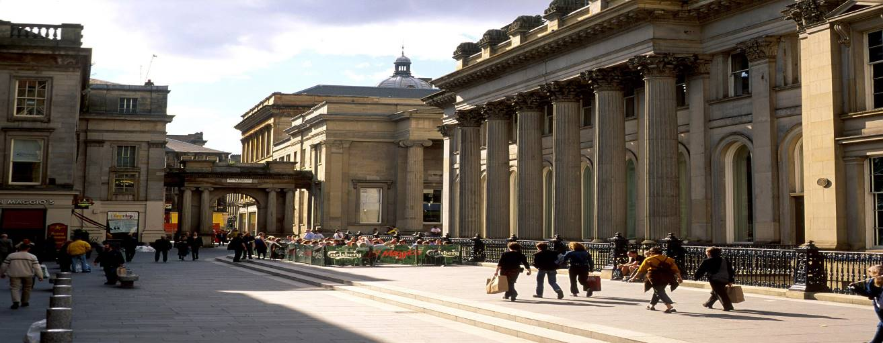

Enjoy a private tour surrounding the Mackintosh Glasgow School Art. During this hour long tour you will discover the history of the Mackintosh building at the GSA and view some of Charles Rennie Mackintosh’s most iconic pieces along with some of his lesser known designs. There will unfortunately be no access to the Mackintosh building itself as it is undergoing restoration due to the devastating blaze in 2014.

After your tour you will meet with your private guide who will introduce you to Glasgow city centre and enjoy lunch in the city at your leisure.

In the afternoon, join your driver and guide to the West End of Glasgow and visit some of the boutique clothing stores and textile shops.

Journey back to your hotel in the later afternoon and enjoy the evening at leisure.

**Overnight Accommodation Cameron House Hotel, Loch Lomond**

**Day 2 – Day at Leisure:**

This morning after a delicious breakfast at your hotel, enjoy the day completely at leisure at the Cameron House Resort. Enjoy some of the on-site activities or simply relax in the spa.

**Day 3 – Day Touring Loch Lomond:**

This morning after breakfast, depart with your driver and guide to explore the Loch Lomond an d Trossachs National Park.

Firstly visit the country textile shops at the town of Balloch before a trip to the picturesque village of Luss.

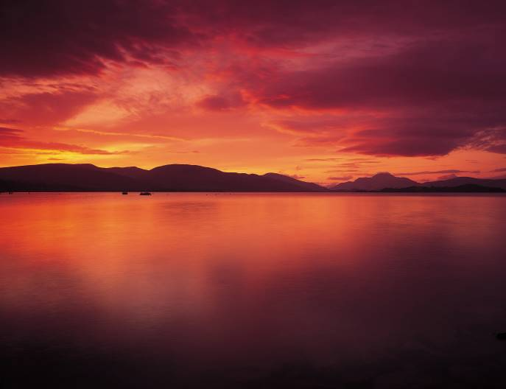

**Loch Lomond:**

Lying on the Highland Boundary Fault, Loch Lomond is the largest body of freshwater in mainland Britain. Being 24.5 miles (39 km) long, it is the largest freshwater loch in Scotland and has more than 30 islands, the largest of which is Inchmurrin. The Loch Lomond and Trossachs area of Scotland was awarded National Park status in July 2002 and is today used by generations of Scots and visitors for boating, water skiing, bathing and picnicking, or just enjoying the unique atmosphere and scenery.

After lunch, depart with your driver and guide for the village of Mearns in Renfrewshire. Spend short time in village and pay a visit to the Mearns Maxwell Parish Church which incorporates the Mearns Castle Tower.

Journey back to Cameron House for your overnight.

**Overnight Accommodation Cameron House Hotel, Loch Lomond**

**Day 4 – Loch Lomond to Isle of Eriska:**

Late in the morning, check out of your hotel, meet with your driver and guide and depart for Oban area.

Your journey will run along the side of Loch Lomond before crossing over to Loch Fyne and eventually Loch Awe.

Stop off at the Loch Fyne Oyster Bar to have an early lunch.

Continue on towards Inveraray

**Inveraray:**

The ancient Royal Burgh of Inveraray is located 60 miles north west of Glasgow by Loch Fyne in an area of spectacular natural beauty. The ruggedness of the

highland scenery serves as a spectacular backdrop for a sheltered tidal Loch, beside which nestles the present castle built between 1745 and 1790. Much of the town, including the church, was designed and built by the Edinburgh-born architect Robert Mylne between 1772 and 1800.

Pay a visit to Inveraray Castle for a private tour.

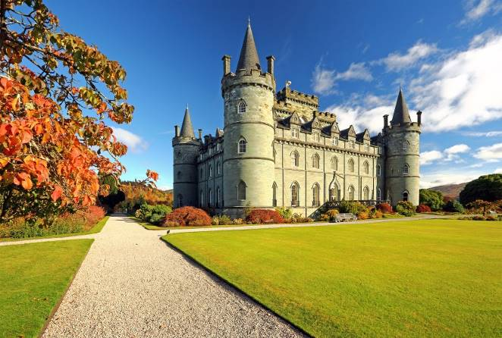**Inveraray Castle:**

Inveraray Castle is the ancestral home of the Duke of Argyll, Chief of the Clam Campbell and the iconic, must-see visitor attraction on the West Coast of Scotland. Most notably, Inveraray Castle featured in the television drama "Downton Abbey". Inveraray Castle is a unique piece of architecture and was the first of its size and type to be built on the West Coast of Scotland. Visitors to the Castle will be able to explore the many historical rooms available to the public, and helpful guides will answer any questions you might have.

Onward further you will then reach the Inverawe Smokehouse.

**Inverawe Smokehouse:**

Inverawe Smokehouse had its origins when Robert and Rosie Campbell-Preston started smoking fish in their back garden by the banks of the River Awe more than 35 years ago. Their Scottish smoked fish is now sought after around the world. Come and see what they do best. View the smokery at work, browse round the smokery shop & tearoom or simply enjoy the flora and fauna of this beautiful corner of Argyll. Inverawe Visitor Centre is a delightful place to get away from it all! Completely unspoilt, with an abundance of both flora and birds you can just walk a nature trail through woodlands and parkland.

Continue your journey towards your hotel and check in.

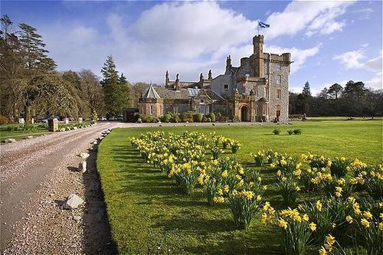**Isle of Eriska Hotel & Spa:**

The Eriska Hotel and Spa offers 5 Star accommodation with a view to match. Set within it's mature gardens and located on its own island this traditional Scottish Mansion House offers its guests 25 luxurious rooms including deluxe and suites levels. The property has extensive leisure facilities including an indoor arena offering tennis, badminton and mini golf. A luxury Spa offers treatments and products by ESPA including Day Packages or one off treatments. An indoor swimming pool compliments the facilities. The Hotel also features a small lounge and bar withe a central lounge for relaxing or sampling a Scottish tipple! Since 1997 the Restaurant at Eriska has held the award of 3 AA Rosettes and a mark in the Good Food Guide. You are assured of a warm welcome and a memorable stay at Eriska.

**Overnight Accommodation Isle of Eriska Hotel, Argyll**

**Day 5 – Full Day Trip to Mull:**

After a lovely breakfast depart the hotel and head to the port in Oban for a day trip to the Isle of Mull.

The short crossing of 45 minutes each way makes it an easy accessible day trip, arriving at Craignure.

**Isle of Mull:**

Mull is the largest of the islands of Argyll and the third largest in Scotland, with 300 miles of coastline. At its heart lies Ben More, a Munro with an elevation of 3,169 ft, which is a popular climb and the island has many other fine hill walks of varying degrees of difficulty. Having been inhabited since the last ice age, it has a rich cultural heritage and is home to many historical sites and monuments. Beautiful beaches and bays abound, from Calgary and Kilninian in the north to Loch Buie and Carsaig in the south. Mull has an abundance of wildlife on its land and in its waters, with curious puffins on surrounding seabird colonies and great whales and basking sharks swimming just off the coast.

Visit Duart Castle:

Dating from the 13th century and spectacularly situated on a clifftop overlooking the Sound of Mull, Loch Linne and the Firth of Lorne, this imposing castle has been the base of Clan MacLean for over 400 years. Duart was originally a rectangular wall enclosing a courtyard, but later in the mid 17th century the castle was extended with the addition of small vaulted cellars and a two story gatehouse. In 1691 the Macleans surrendered Duart and all their lands on Mull to the Duke of Argyll. The castle, although in a fairly ruinous condition was used as a garrison for government troops until 1751. It was abandoned until 1910 when it was purchased by Sir Fitzroy Maclean, 26th chief. He then set about the enormous task of restoring the building to its present condition.

Visit the pictureqsye main town on the island: Tobermory.

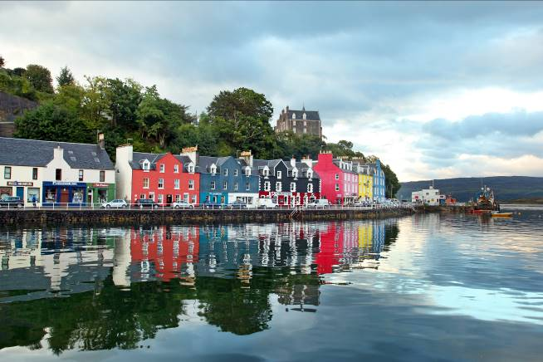

**Tobermory:**

Tobermory is the main town on the island of Mull, in the Inner Hebrides. The picture-postcard port with its brightly coloured harbour-front buildings is one of the prettiest ports in Scotland, thanks to the colourful houses and a sheltered bay where legend has it one of the Spanish Armada ships sank in 1588 carrying gold bullion. Built as a fishing port in 1788 on a design by Thomas Telford, the town curves around the harbour and rises into the hillside beyond.

Travel back to Oban and spend a short time exploring the seaside town with your guide.

**Oban:**

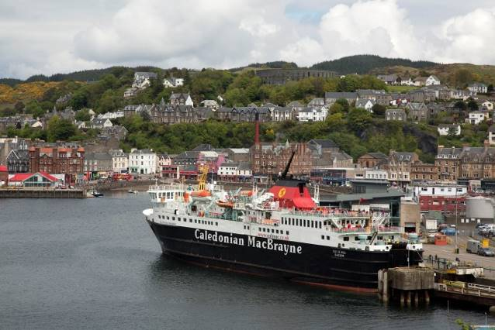As you sweep down the hill towards the expanse of the bay, the view opens up before you and one begins to appreciate why Oban has developed into Scotland's most popular west-coast holiday town. With a resident population of 8,500, Oban has recently become better known as "The Seafood Capital of Scotland". The panoramic views of the mountains, lochs and islands which have captivated artists, authors, composers, and poets for centuries are as striking now as they were when Dunollie Castle, a ruined keep, was the northern outpost of the Dalriadic Scots. The town's present day popularity owes much to the Victorians, and as early as 1812, when the Comet steamship linked Oban with Glasgow. Indeed once Oban had the royal seal of approval from Queen Victoria, who called it "one of the finest spots we have seen", the town's destiny as an endearingly enchanting holiday destination was as firmly set as the lava columns of Fingal's Cave in Staffa.

Your driver and guide will escort you back to your hotel for overnight.

**Overnight Accommodation Isle of Eriska Hotel, Argyll**

**Day 6 – Argyll to Inverness:**

This morning after breakfast, check out and depart your hotel with your driver and guide in the direction of Inverness.

You will pass by Ben Nevis where you can stop for a photo opportunity.

You will then visit Loch Ness.

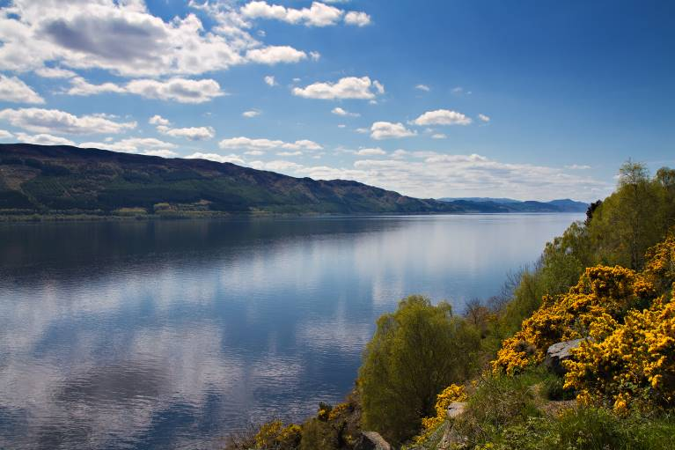**Loch Ness:**

Loch Ness is the deepest freshwater loch in the Scottish Highlands, and is one of the most visited locations in Scotland. Loch Ness is about 24 miles long by one mile wide and at its deepest point, it goes down nearly 1,000 ft. Lying northeast of the Great Glen in the Highlands, Loch Ness is best known for alleged sightings of the crypto-zoological Loch Ness Monster, also known affectionately as "Nessie".

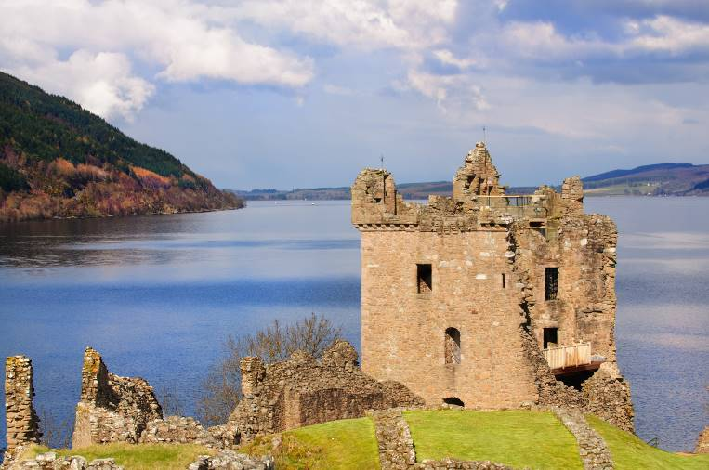**Urquhart Castle:**

Urquhart Castle offers a taste of the Highlands at their most dramatic. Discover 1,000 years of drama, experience a glimpse of medieval life and enjoy stunning views over Loch Ness from the ruins of the greatest castle in the Highlands. Urquhart’s stories are also told through a remarkable collection of artefacts left by its residents, historic replicas, including a full-sized, working trebuchet siege engine. The castle has a distinctly Highland heritage and the site has witnessed some of the most dramatic chapters in our nation’s history. It is here that St Columba is said to have worked miracles in the 6th century, where acts of chivalry and defiance provided inspiration during the Wars of Independence and where the MacDonald Lords of the Isles struggled with the Crown for power.

Continue on to Inverness for a short tour.

**Inverness:**

Crowned by a pink crenelated castle and lavishly decorated with flowers, Inverness is a thriving city boasting historical buildings in the Old Town and peaceful areas close to the centre. This thriving city offers a rich variety of things to do and see from culture to eating and drinking. Enjoy the fine circular walk from Inverness Castle, currently a courthouse, along the river past St Andrew’s Cathedral, which dominates the River Ness, and through the Ness Islands where you will find anglers casting long lines to leaping Atlantic salmon.

Check in to your accommodation.

[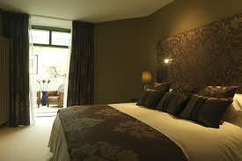](http://www.google.ie/url?sa=i&rct=j&q=&esrc=s&source=images&cd=&cad=rja&uact=8&ved=0CAcQjRw&url=http://www.boath-house.com/rooms/room-seven/&ei=kZcSVamkL5CO7Ab3k4HgCg&bvm=bv.89184060,d.d24&psig=AFQjCNHZMZ2L6bCu1xo-Cu0hwvexzwCxkQ&ust=1427368184789024)**Boath House Hotel:**

2010 marked the 20th anniversary in this unique and beautiful home and to complete a great anniversary year Boath House won the coveted [AA Scottish Hotel of the Year award](http://www.boath-house.com/about-us/awards/) that year. The property is set in 22 acres including well tended lawns, [gardens](http://www.boath-house.com/about-us/gardens/), woodland and streams. A natural lake viewed from the house is stocked with brown and rainbow trout and is also home to swans, wild geese and ducks. A series of well-kept paths connect with the house to enable guests to explore the wild flower meadow, the walled garden, to rest and relax on the lawns, secluded seating areas or on sunny terraces. A series of well-kept paths connect with the house to enable guests to explore the wild flower meadow and the walled garden.

**Overnight Accommodation Boath House Hotel, Nairn**

**Day 7 – Inverness to Edinburgh:**

This morning after breakfast, check out of your hotel and depart for Edinburgh.

Stop at the Highland Folk Museum in Newtonmore.

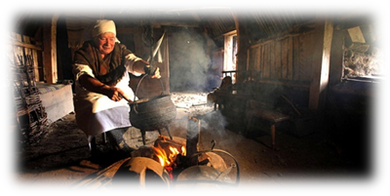

Delve into 18th century Scotland at the **Highland Folk Museum**, a living history site offering a unique insight into the life of Highland people. With live actors and restored buildings, learn how they lived and work. The museum is home to the *Baile Gean township*, complete with turf houses, which features extensively in *The Outlander*.

Onward further you will reach the highland town of Pitlochry.

**Pitlochry**

The bustling town of Pitlochry is a gateway to the Highlands. It's a popular town with great scenery and home to Scotland's smallest distillery. Just off the main A9 route north, the town is a busy stop-off point for people heading into the Highlands. It benefits from a lovely setting on the River Tummel, backed by Ben Vrackie, and is particularly beautiful during the changing colours of autumn.

Once again depart Southwards towards Edinburgh.

En-route you will pass through Perth

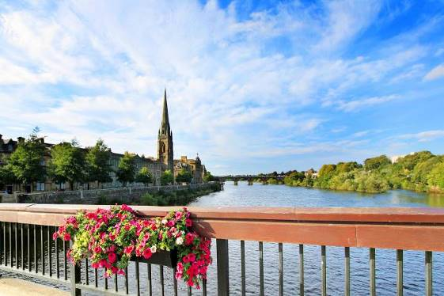

**Perth** sits on the banks of the River Tay and was made a city again by the Queen as part of her Diamond Jubilee celebrations in 2012. It is a large provincial area and the main administrative and cosmopolitan centre for the beautiful surrounding 2,000 square miles of Perthshire. With a rich and influential history that stretches back over 800 years, Perth has served as its country's capital and has always been one of the most important political, judicial and commercial centres in Scotland. Many of the Scottish kings were crowned on the Stone of Destiny at Scone Palace, while there are many famous historical figures who left their mark on this royal burgh. Today, Perth is a bustling city of around 50,000 inhabitants and is recognised as one of Scotland's premier culinary centres.

You will then cross the Forth road bridge and can its neighbour the Forth Road Bridge:

**Forth Rail Bridge:**

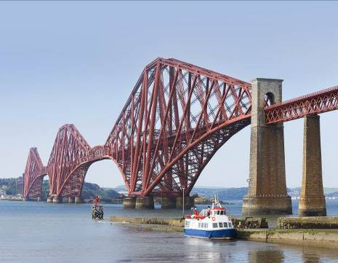Opened in 1890, the Forth Bridge is a Scottish icon that is recognised the world over for its magnificent structure, its distinctive design and red oxide-coloured paint. As the world's first major steel structure, it represents a key milestone in the history of modern railway civil engineering and still holds the record as the world’s longest cantilever bridge. A full-scale restoration project to return the bridge to its original construction condition was completed in 2012 and a UNESCO World Heritage nomination has been submitted.

Onward still to Edinburgh where you will check in to your hotel. Bid farewell to your driver and guide.

**Edinburgh**

Edinburgh, the inspiring capital of Scotland, is a historic, cosmopolitan and cultural city. The setting is wonderfully striking: a city is perched on a series of extinct volcanoes and rocky crags, which rise from the generally flat landscape of the Lothians, with the sheltered shoreline of the Firth of Forth to the north. Edinburgh Castle dominates the city-centre skyline and from its ramparts you can look down on medieval lanes and elegant, sweeping terraces that hold over a thousand years of history, mystery and tradition. Yet Edinburgh is also a modern, dynamic capital where international festivals attract the world's leading performers, galleries display cutting-edge art, and bars, restaurants and clubs create a lively, cosmopolitan atmosphere with a distinctly Scottish twist. 'Edinburgh,' said writer Robert Louis Stevenson, 'is what Paris ought to be'.

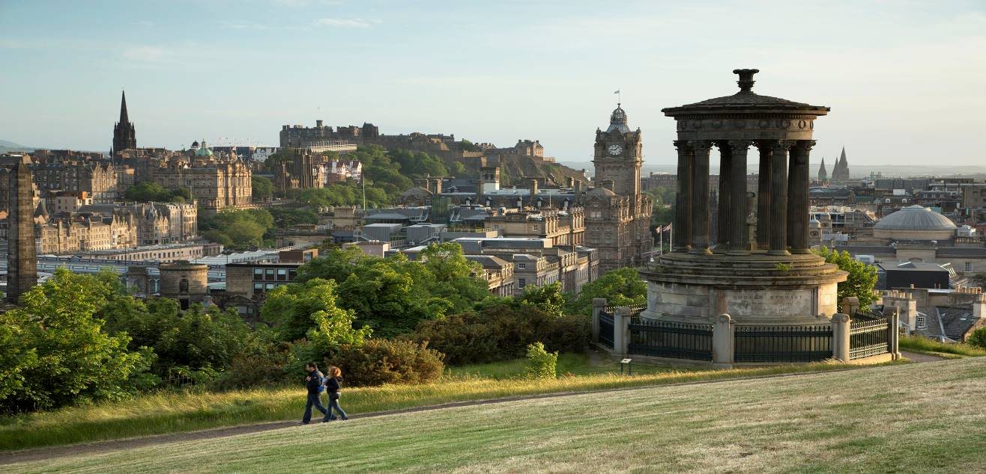

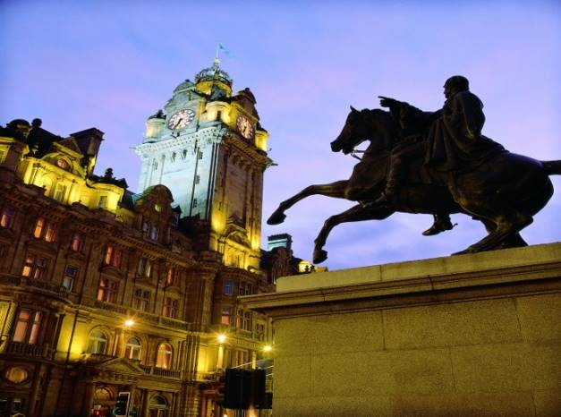**Balmoral Hotel:**

The Balmoral is a stylish property in the heart of Edinburgh on the famous Princes Street. Within easy walking distance of shopping and all the main attractions in the city, the hotel is home to the only Michelin-starred hotel restaurant in Edinburgh, the Number One. Guests can also enjoy the award-winning Spa, with its 15 metre pool, treatment rooms and fully-equipped gym. The hotel has 188 bedrooms ranging from Classic to Deluxe suites and is considered one of Edinburgh finest Hotels**.** Originally built as one of the great railway hotels of Britain, the Balmoral Hotel has been welcoming guests for over a century. This dedication to perfecting the most luxurious stay has firmly cemented the hotel as one of the finest Edinburgh has to offer.

**Overnight Accommodation Balmoral Hotel, Edinburgh**

**Day 8 – Edinburgh:**

This morning enjoy a half day walking tour of Edinburgh Old Town with a visit to Edinburgh Castle.

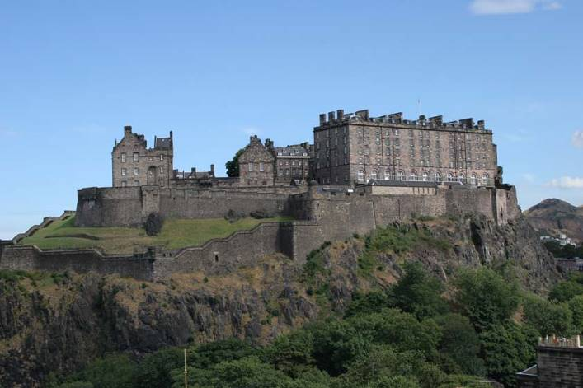**Edinburgh Castle:**

Edinburgh’s Castle rock has been a stronghold for over 3000 years. In its dominating position overlooking the capital city, the grandeur and historical significance of Edinburgh Castle has made it a globally famous icon of Scotland and part of the Old and New Towns of Edinburgh World Heritage Site. Sited on top of an extinct volcano, gaining stunning views across City of Edinburgh, the castle has witnessed many of the defining events of Scottish history and has dominated its surroundings with majesty for centuries. Captivating visitors with its ancient buildings and marvellous views, it continues to spellbind with its wonderful story.

In the evening, visit the world famous Edinburgh Military Tattoo. You will experience the Amber package.

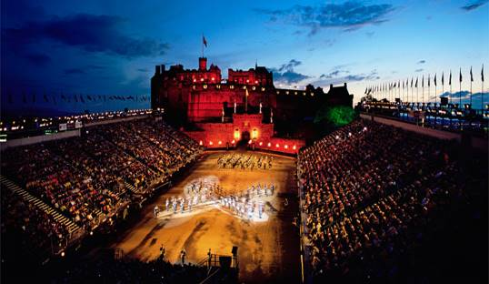Edinburgh Military Tattoo

The Royal Edinburgh Military Tattoo is the most spectacular show in the world, enjoyed by an international television audience of 100 million. In the glowering twilight, Edinburgh Castle slumbers, resting, waiting for nightfall and for the footlights that will transform it into a dazzling stage set for the world's most spectacular show. Down Castlehill, people gather in the dusk of a late summer evening turning their faces to the great castle rock, where ancient clans first settled the area, which was to become the capital of Scotland and where now stands Edinburgh's mighty fortress.

**August Only.**

Amber Package Includes:

* A three course specially selected Scottish menu with half a bottle of wine and a dram of Whisky with dessert, followed by coffee/tea and Scottish fudge
* Your very own copy of the menu with a map of Scotland highlighting the regions from which your food was sourced
* A brief recital from members of the Tattoo cast
* A host to escort you from The Scotch Whisky Experience to the Castle Esplanade
* A seat in [**Section 7**](http://www.edintattoo.co.uk/hospitality/seating-options/stand-seating) of the outdoor arena with exceptional views of the performance or a VIP seat in the covered [**Royal Gallery**](http://www.edintattoo.co.uk/hospitality/seating-options/royal-gallery)
* An official Tattoo Show Programme

**Overnight Accommodation Balmoral Hotel, Edinburgh**

**Day 9 – Edinburgh:**

This morning after breakfast, meet with your private driver and guide and depart for Stirling for a full day tour.

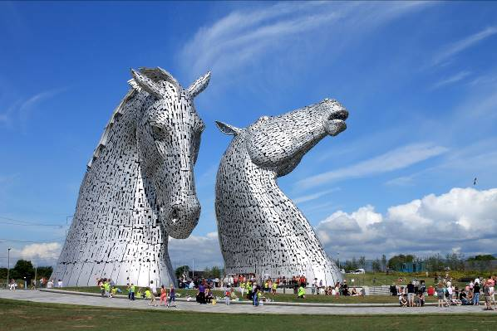

On your way stop off at the Kelpies where you guide will talk about their inception and creation along with the history of the Fourth and Clyde canal that runs by the site.

Enjoy a tour that will also bring you inside the mammoth sculptures.

Continue on to the city of Stirling

**Stirling:**

Stirling is Scotland's heritage capital, where the Wars of Independence were fought and won, where for three centuries monarchs ruled in regal splendour and where merchants and craftsmen plied their trade below the castle rock. Nowadays you can feel the sense of history and nationhood which is Stirling's trademark, as you enter the spectacular castle perched high above the city. The compact heritage mile that links Stirling's Old Town with its bustling modern city centre boasts the finest concentration of historic buildings in Scotland. Beautifully preserved medieval and Renaissance churches and mansions cluster around the Old Town, flanked by cobbled streets, period street furniture and Victorian styled iron work. Overlooking the scene of one of Scotland’s most famous battle sites, Stirling Bridge, is the 220 ft high National Wallace Monument.

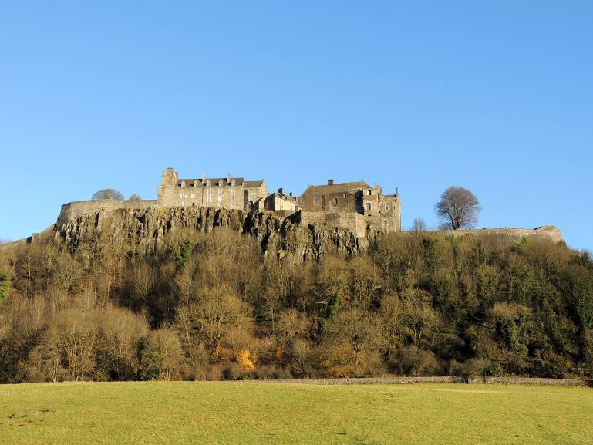**Stirling Castle:**

One of Scotland’s grandest castles due to its imposing position and impressive architecture, Stirling Castle commands the countryside for many miles around. It towers over some of the most important battlefields of Scotland’s past including Stirling Bridge, the site of William Wallace’s victory over the English in 1297, and Bannockburn where Robert the Bruce defeated the same foe in the summer of 1314. Situated on a volcanic outcrop guarding the lowest crossing point of the River Forth, Stirling Castle is a great symbol of Scottish Independence and a source of enduring national pride. The castle’s long, turbulent history is associated with great figures from Scotland’s past, such as William Wallace, Robert the Bruce and Mary Queen of Scots. It has seen many royal dramas and witnessed the lives and deaths of almost every Scottish monarch up to the Union of the Crowns in 1603.

In the afternoon, journey back to Edinburgh to spend the evening at leisure.

**Overnight Accommodation Balmoral Hotel, Edinburgh**

**Day 10 – Edinburgh:**

This morning after breakfast, depart with your driver and guide for St Andrews in Fife.

**Kingdom of Fife:**

Ancestral home of Scottish monarchs, The Kingdom of Fife is a proud region with its own distinct identity. Home to Scotland's capital for six centuries, Fife has always been at the heart of the nation's history, evidence of which can still be found in its wealth of castles, cathedrals, and places of historic interest. The Kingdom of Fife is also known throughout the world as the Home of Golf and boasts more than forty courses, from the famed fairways of St Andrews and several traditional seaside links to beautifully landscaped parkland and heathland courses suitable for golfers of all levels.

**St Andrews:**

St Andrews is a charming and historic town that attracts visitors from all over the world. Known worldwide as The Home of Golf, the town also boasts Scotland's oldest university. The St Andrews Royal and Ancient Golf Club first met here in the spiritual home of golf in 1754, though it was first played here as early as the 15th century. St Andrews University, founded in 1410, dominates the centre of town. The elegant, ivy-clad buildings and delightful quadrangles and gardens have seen a procession of famous graduates such as Prince William. One of the top universities in Britain, St Andrews is often compared to Oxford and Cambridge for its defining presence and the collegiate feel it gives to the town. St Andrews has also two great beaches, one being the magnificent West Sands, where the famous opening sequence of Chariots of Fire was shot.

Enjoy a spot of lunch overlooking the 18th green at the Old Course.

Visit St Andrews Cathedral.

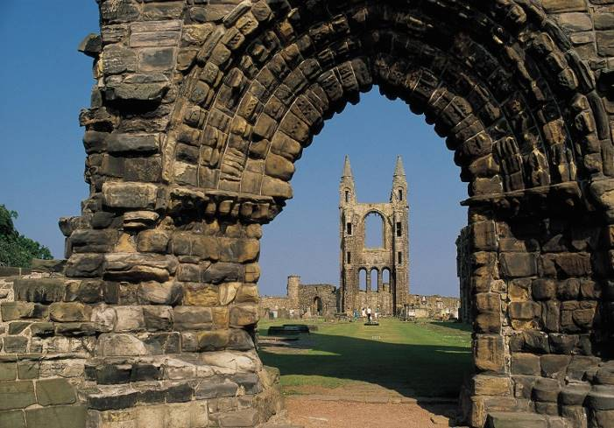**St Andrews Cathedral:**

The remains of what was Scotland’s largest and most magnificent church still show how impressive St Andrews Cathedral must have been in its prime. St Andrews Cathedral dominated the history of the medieval Church in Scotland, from its construction in the 12th century until the Protestant Reformation in 1560. As Scotland’s largest and most magnificent medieval church, the cathedral was the seat of the country's leading bishops. It occupied a site used for worship since the 8th century AD, when the relics of St Andrew, Scotland’s patron saint, are said to have been brought here. The cathedral buildings are surrounded by a graveyard, and encircled by the most complete and imposing monastic enclosure walls in Scotland.

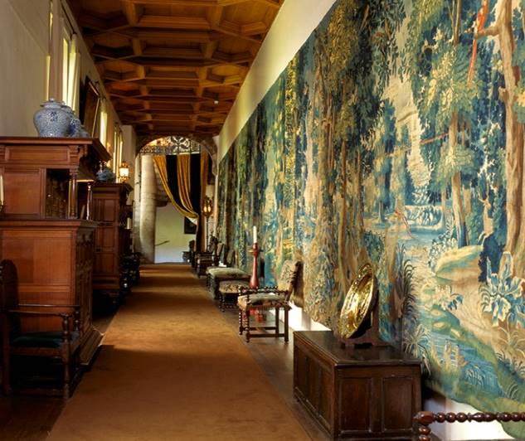**Falkland Palace:**

Falkland Palace is an impressive Renaissance building set in the heart of the town, at the foot of the Lomond Hills. Built by James IV and James V between 1501 and 1541, the Palace was a country residence of the Stuart monarchs of Scotland for over 200 years. Lush green lawns, colourful herbaceous borders and many unusual shrubs and trees complete the setting for this memorable property. Experience a day in the life of the Stuart monarchs at Falkland Palace, their country residence for 200 years – and a favourite place of Mary, Queen of Scots. The original and reconstructed rooms are packed with 17th-century Flemish tapestries, elaborate painted ceilings and antique furnishings. The beautiful, tranquil grounds are worth a visit alone. They’re home to the oldest real (or royal) tennis court in Britain, built for King James V, as well as a gardens designed by Percy Cane.

Travel back to Edinburgh with your driver and guide for your overnight.

**Overnight Accommodation Balmoral Hotel, Edinburgh**

**Day 11 – Edinburgh:**

This morning after breakfast, spend the day at leisure in the city. Visit some of the designer boutique on George Street perhaps.

In the evening it is recommended to dine at The Loch Fyne Seafood & Grill where you can enjoy some delicious Scottish caught oysters.

**Overnight Accommodation Balmoral Hotel, Edinburgh**

**Day 12 – Edinburgh:**

This morning, check out of your hotel and depart with your driver for Glasgow airport for your onward flight.

**Bid Farewell to Scotland**

*Please note that day-touring with your private driver is up*

*to a maximum of 8 consecutive hours per day.*